# 

# 

# 

# 

# 

# 

# Trashed

*Megan Behnke | Brandon Chen | Heesun Eom | Kevin Zellers*

DSGN 308

June 10, 2016

**Table of Contents**

1. List of Figures……………………………………………………………………………………………………....3
2. List of Tables………………………………………………………………………………………………………..3
3. Executive Summary…………………………………………………………………………………………….. 4
4. Introduction………………………………………………………………………………………………………...5
5. Problem Definition………………………………………………………………………………………………6
6. Need Finding Research………………………………………………………………………………………....8
7. Personas and Users…………………………………………………………………………………………….10
8. Competitive Benchmarking………………………………………………………………………………...11
9. Brainstorming and Concept Refinement……………………………………………………………...13
10. The Design…………………………………………………………………………………………………………16
    1. Product Summary…………………………………………………………………………………....16
    2. Trash Can Attachment……………………………………………………………………………..16
    3. Bag Clip with Torsion Spring…………………………………………………………………….16
    4. Friction Surfaces with Plasti-Dip………………………………………………………………17
11. Requirements and Specifications………………………………………………………………………...18
12. Looks-Like and Works-Like Prototypes……………………………………………………………….19
    1. Early Prototypes……………………………………………………………………………………...19
    2. Final Prototype………………………………………………………………………………………..20
    3. Manufacturing and Assembly…………………………………………………………………...21
13. Looks-Like and Works-Like Prototype Testing……………………………………………………..21
    1. User Testing…………………………………………………………………………………………….21
    2. Static Load Test……………………………………………………………………………………….22
    3. Dynamic Load Test…………………………………………………..……………………………....22
    4. Cleanliness Test……………………………………………………………………………………….23
    5. Findings and Insights……………………………………………………………………………….24
14. Future Steps……………………………………………………………………………………………………....24
15. Differentiation……………………………………………………………………………………………………25
16. References…………………………………………………………………………………………………………26
17. Appendices………………………………………………………………………………………………………..27
    1. Initial User Survey Responses………………………………………………………………….27
    2. Patent Research………………………………………………………………………………………………...29
    3. Angle Determination…………………………………………………………………………………………30
    4. Performance Testing Results……………………………………………………………………………...31
    5. Final Prototype User Testing……………………………………………………………………………...32
    6. Dimensioned Drawings…………………………………………………………………………………..…33
    7. Bill of Materials………………………………………………………………………………………………...36

**List of Figures**

1. Final Prototype of the Clip-It…………………………………………………………………………………………………………4
2. Rendering of the unobtrusive Clip-It in a typical house…………………………………………………………………..4
3. Survey results for the question “What is the biggest problem you have with your trash can?”................6
4. Survey results for interest in a product that could solve the two largest issues with trash…………….....6
5. Trash Cans on the market currently……………………………………………………………………………………………...8
6. uxcell® Plastic Garbage Rubbish Trash Can Bag Clip Clamp Holder……………………………………………....11
7. DELIFUR(TM) 12 Pieces Plastic Clip Clamp Holders, for Garbage Can…………………………………………...12
8. Results from brainstorming session……………………………………………………………………………………………..13
9. Hooks, magnets, latches, and clamps are all mechanisms identified as potential solutions……………...14
10. Adhesive could be used as part of the trash bag mechanism itself………………………………………………....14
11. Roll of trash bags in bottom of can, spill catcher…………………………………………………………………………....14
12. CAD rendering of Prototype…………………...…………………………………………………………………………………....16
13. Clip-It on normal kitchen trash can…………...………………………………………………………………………………....16
14. Initial mechanical mockups…………………...…………………………………………………………………………………....19
15. Sleek, modern alternative mockup…………...……………………………………………………………………………….....19
16. 3D printed alternative……………...…………...………………………………………………………………………………….....19
17. Second iteration of first set of mockups……...…………………………………………………………………………...…...20
18. Initial 3D print of design…………....…………...…………………………………………………………………………………...20
19. Second iteration 3D print………....…………...…………………………………………………………………………………....20
20. Final Prototype………....…………...……………………………………………...…………………………………………………...20
21. The Clip-It holding 25 lbs, with only one of four clips undone by the weight……………...……………….....22
22. 3 pound weight being dropped into trash bag with Clip-Its attached…...………………………………………..23
23. Clip-It drenched in ketchup, oil, and worcestershire sauce for cleanliness test……………………………....23

**List of Tables**

1. Torsion Spring Properties…………………...………………………………………………..……………………………………...16
2. Cost of Injection Molding…………………...………………………………………………..……………………………………….18
3. Costs of Injection Molding the One Form and Clip-It Iterations……………………………………………...…..…..25

# Executive Summary

This report introduces the Clip-It, a product designed to prevent a trash bag from falling into a trash can, which causes the can to get dirty, as well as being a hassle to constantly fix. This product was designed and developed using the human-centered design approach. This includes conducting user surveys and observations in order to find a problem that is prevalent, research patents in the space of the problem, competitive benchmarking with products on the market that may or may not solve the problem, finding the white space around this issue, and an iterative design process. The result of this process lead to the Clip-It.



**Figure 1:** Final Prototype of the Clip-It

To solve the problem of the bag falling into the trash can, the Clip-It utilizes a mechanism similar to that of a binder clip, which is a common workaround to this trash problem. Where the Clip-It differentiates itself from any “over-the-bag” solution is the function of the Clip-It where it specifically goes underneath the bag, and rests on top of the rim of the can. This feature keeps the Clip-It cleaner for a longer period of time as it is covered and protected from trash by the bag itself. This also means that the Clip-It remains on the trash can after each successive trash bag replacement, foregoing the need to take off and replace any of the other products or workarounds.

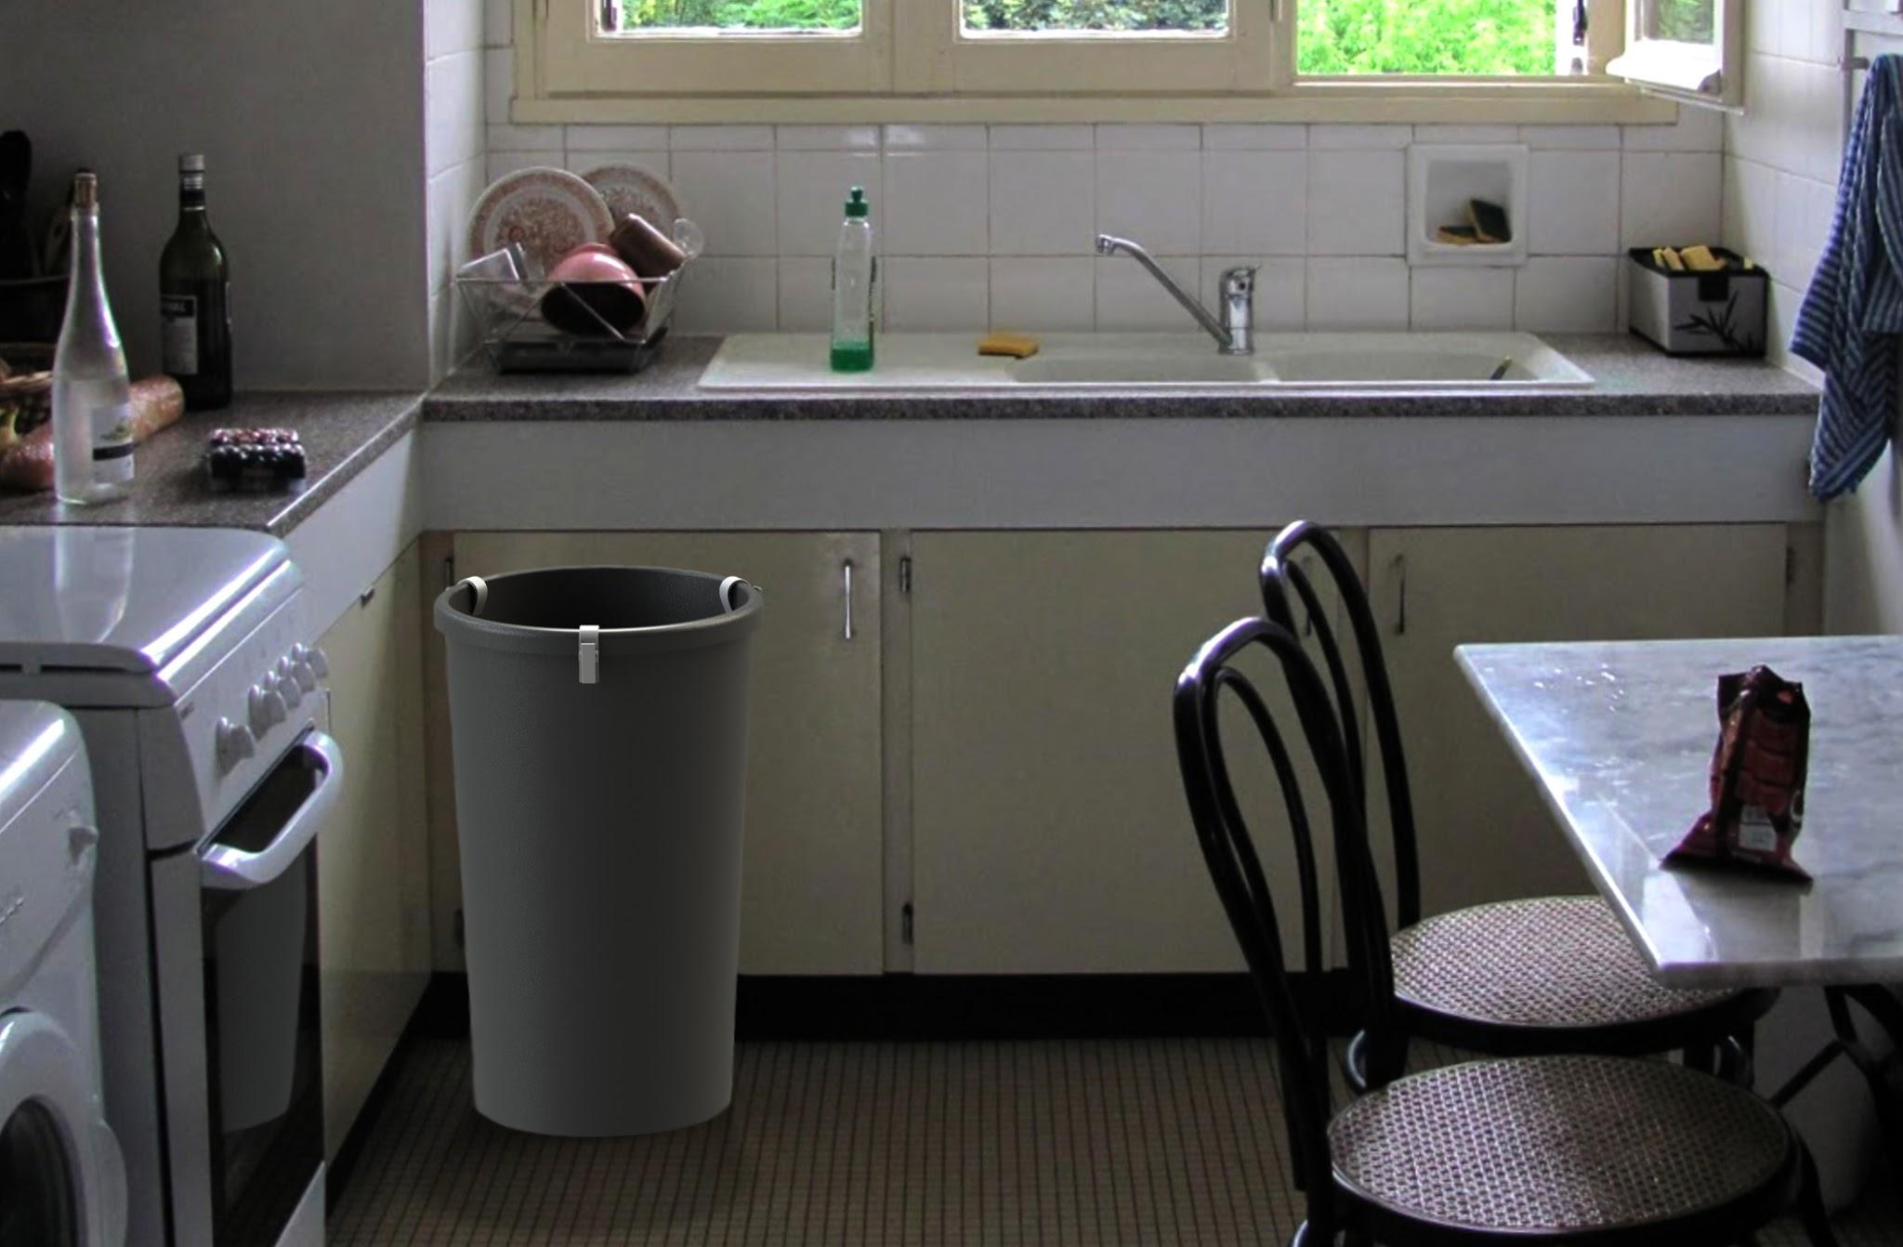

**Figure 2:** Rendering of the unobtrusive Clip-It in a typical house

The development of a product that prevents a trash bag from falling into a trash can, preventing unsanitary and gross conditions in that can, and aids a seamless trash experience has been successfully fulfilled through the design and prototyping of the Clip-It.

# Introduction

Garbage is inherently dirty, and the process of producing, handling, and dealing with garbage tends to be as well. Trash cans interact with garbage and usually end up as dirty as the garbage itself. Especially kitchen trash cans can accumulate undesirable stains that cause stench or may even worse, host health hazardous bacteria. When these wet garbage miss the trash bag and end up staining the trash can, it can be left there for weeks eventually rotting or even worse attracting flies and causing a maggot infestation. The handling of trash is perhaps the most underrated form of dirtiness in a kitchen, but homeowners rarely do anything about it because trash is supposed to be gross, and put simply, people do not want to deal with it. It is a hassle when trash bags fall in because no one wants to be touching foul garbage, and it is hard and disgusting to have to clean a trash can because a trash bag is meant to keep the can clean.

When people throw away trash, they rarely think about the state of the trash bag before and after they throw away their garbage. Trash bags constantly fall in the can from wet garbage, projectile garbage, and natural circumstances. When a trash bag falls into the can, many people do not want to deal with it at the moment because the trash is gross. They ignore the fallen trash bag and continue to throw away trash as if the bag was in place. So, as the garbage piles up, the trash bag gets lost under the trash and when it’s time to take out the trash, one must reach into the can and find the bag. In addition, the can is now dirty from all the trash that did not make it into the buried bag. To maintain a healthy household this trash can must be cleaned out before a new trash bag should be put on. Often case, it is not cleaned. Is there not a way to deal with preventing this from happening so often?

Currently, the only solution the market provides is to purchase a new, expensive trash can that has some feature that holds the bag, whether it be a lid, clamp, etc. However, there are no products in the market that provides a solution to one’s existing minimalistic kitchen trash can. There are a few workarounds that people use such as clipping binder clips over the trash bag on to the rim of the can. Although this workaround prevents the bag from falling, the binder clips can get very dirty as it is exposed to the garbage. They must also be removed and replaced after every time the garbage is taken out.

A product that prevents the bag from falling in while in use, that will not get dirty over multiple uses, that can hold a full weight’s worth of trash, and that can remain on the trash can between bag changes is needed.

This report presents the story of the final product: how it originated, how it was tested, and how certain design decisions were made. Through patent research, competitive product testing, user surveys, and performance testing, an innovative design for a well-defined and tested white-space has been accomplished. Through all of this, a product was designed that attempts to solve all the above problems, introducing the “Clip-It”.

# Problem Definition

Dealing with trash in the home is an issue for many people. In an initial survey with 23 responses of respondents who agreed that they had problems with their trash cans, the majority of people’s pain points centered on the fact that the trash bag falls in. A secondary concern was the fact that the trash can gets dirty with food, which many attributed to the trash bag falling into the can.

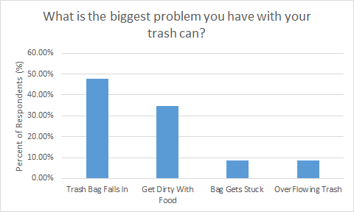

**Figure 3:** Survey results for the question “What is the biggest problem you have with your trash can?”

As seen in the above survey, 47.8% of people said that the trash bag falling in was their biggest problem, and 34.8% of people said that the can becoming dirty with food was their biggest problem. What causes the bag to fall in, or for the can to get dirty with food? From responses received, some benchmark testing, and research, it seemed a common thread was that the bag falls in. Bags tend to fall in when heavy garbage is thrown away, when the trash can fills up, when garbage is thrown from a distance, and sometimes simply it slowly slips in overtime. On the other hand, the can gets dirty with food from full trash bags, poorly aimed throws, and from the bag falling in. In this initial survey, respondents were asked what they thought of a product that could provide a solution for these issues. The results can be seen in Figure 4.

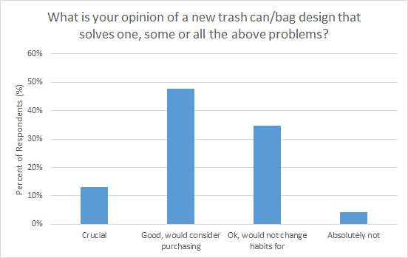

**Figure 4:** Survey results for interest in a product that could solve the two largest issues with trash

13% of respondents thought a solution was crucial, and 47.8% thought the idea was good, and that they would think about purchasing the solution. Based on these results, it was worthwhile to look into finding a solution to the “trash problem” - preventing the bag falling in, in order to keep the can cleaner over longer periods of time.

# 

# 

# Need Finding Research

To determine the need for a product that solves the above issues, it was first important to research what kind of products were currently on the market in order to get a better idea of what attempts had been made to counter these issues. Figure 5 shows some examples of the trash cans researched.

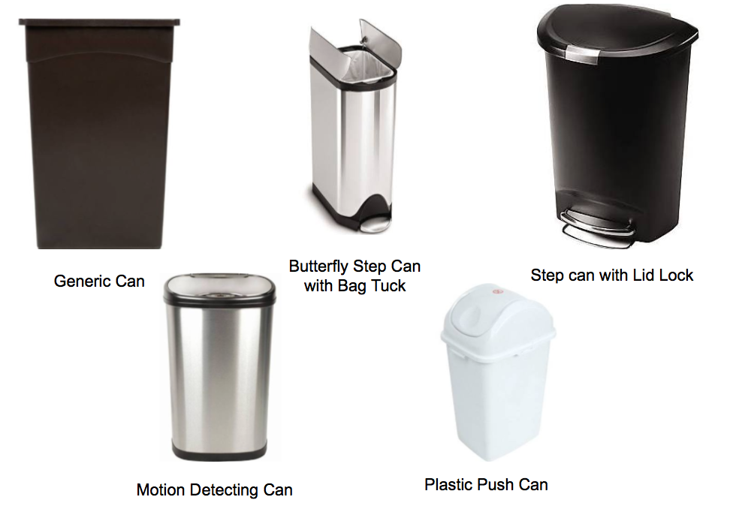

**Figure 5:** Trash Cans on the market currently

The butterfly step can solution is able to hold the bag in place, and is also able to keep odors in because of its lid. However, with so many moving parts, it is somewhat hard to clean if trash gets in any crevices. As for the step can in the top right, the lid will hold the bag while it is closed, but as soon as the lid is opened, there is nothing stopping the bag from falling in. With the motion detecting can, there is no need to even touch the can, but when the lid opens there is nothing holding the bag in place. The push can in the bottom right attempts to solve this by having the lid always on and the user must push the revolving lid to throw food away. However, this opening is now made much smaller from the revolving part, and since the lid is made of plastic as well, it is easy for the bag to slip through when it gets heavier. As for the generic can, there is no way to prevent the bag from falling in.

After going through this initial trash can research, one major observation directed the first of the product’s needs and requirements. Every trashcan on the market that had a solution to hold the bag in place cost an exorbitant amount of money. The butterfly trash can costs a whopping $122, and the rest cost nearly around $60 each. The generic trash can on the other hand can be found for as little as $10. With the information that only more high end and expensive trash cans had solutions to this problem, the list of affected individuals was refined to those that would more likely own a cheaper and generic can such as college students, the elderly, and single parents. Most of these types of people already owned trash cans, so the solution must be able to be used in tandem with the already existing can in order to solve the issues associated with a falling bag.

After narrowing this user group, another survey was conducted, receiving 13 responses. Eleven responded that the trash bag falls into the can, and 9 of those said that it occurs from frequently to any time trash was thrown in. When asked what they did currently to solve their problem, many responded that they did not do anything to fix it, but would be interested in a product that alleviated this problem. One user mentioned that he had heard that some people used binder clips on the rim of the can to prevent the bag slipping. When asked what users would like to see from a solution that solved this issue, they responded that they would like a product that was inexpensive, simple and easy to use, easy to wash, aesthetically pleasing, and functional for even the heaviest bags. (See Appendix A for survey details).

In addition, patent research was conducted in the space of preventing the bag from falling into the can using Thomson Innovations. The results of this patent research can be seen in Appendix B.

To assess its potential, this patent search was conducted concerning existing trash bag falling prevention solutions, as well as solutions to other related issues. The success of these patents was then scored using the requirements that the team put together. A patent that minimally addressed or did not address a certain need, such as low maintenance, was rated more negatively in that category, while a patent that strong addressed a need was rated more positively (see Appendix B).

Looking at the aggregated scores of average need fulfillment in the market, there are indeed certain needs in the market that are poorly fulfilled, such as sanitation and ease of bag changing. In addition, the negative aggregate need scores of each respective patent shows that no one patent has wholly met these needs so far. Thus there was a white space for a versatile solution that could additionally focus on the worst-fulfilled needs.

From patent research and the user survey, the needs and requirements that a potential product must fulfill were narrowed down further. For a product to be successful, it must achieve the following:

Primary Product Solution Requirements:

* Holds the bag in place: the product must successfully prevent the bag from falling into the trash can under weight and impact
* Maintainable and sanitary: the product must stay relatively clean and must be easy to clean when necessary
* Simple and easy to use: Must have obvious affordance, and must be able to swiftly operate the product
* Inexpensive: Must not be a significant cost in addition to the already existing trash can
* Must be an improvement over any workaround, such as a binder clip.

Secondary Product Solution Requirements:

* Lightweight: the product must be lightweight and easily used by all demographics (including children and the elderly who may not be able to lift as much)
* Odor-resistant: the product should not retain foul smells from the trash

# Personas and Users

Everyone creates trash, usually disposed of in garbage bags. But before those garbage bags live in dumpsters, they live inside home trash cans, often ill-designed and poorly sized and incapable of securing the bag in place. While seemingly everyone could be in the market for a product to prevent bags from falling into their trash cans, this product appeals to a more specific target market. This product is for the elderly grand fathers with bad backs who can not be constantly reaching deep into their trash cans to fix a fallen bag. This product is for the families with young children who are concerned about sanitation and keeping their trash cans free of bacteria. This product is for the young and busy professional who does not have time to deal with fixing their trash bags, but who also may not yet have much money to buy an expensive, high-tech trash can. This product is for every single time a person who is tired or overwhelmed or lazy looks at their slipping trash bag and says “Not today.” This product is for the single mother who has one arm occupied with a baby, a toddler clinging onto her leg, and only one hand remaining to cook, clean, and play with her children in order to be the “Supermom” that she wants to be for her kids. Her one free hand and precious minutes of her day should not be occupied struggling with a trash bag that simply will not stay put.

For all of these users, trash should not be more of a nuisance than tying off the bag when it is full and taking it to the nearest curbside or dumpster. Their experiences and frustrations facilitates a pattern of learned helplessness, described as a “situation in which people experience repeated failure at a task, [and] as a result, they decide that the task cannot be done…” (Norman, 2013, p. 62). The bag simply never stays put and they are helpless to fix it. Instead of the burden falling on the poorly designed relationship between the trash can and the trash bag, it falls heavily on the user.

From the second a new bag is placed in a kitchen trash can to the time it becomes full, the bag should stay in place and be a hassle-free aspect of the trash experience. Just because a user can not afford or chooses not to buy an expensive trash can does not mean that he/she should suffer the alternative solution of aesthetically displeasing binder clips to hold the bag in place on the can. Every user deserves an unobtrusive, hassle-free solution that is not only inexpensive, but sleek and fits into his/her busy lifestyle seamlessly as well.

# 

# 

# Competitive Benchmarking

Once the solution was refined to a product that should work alongside existing trash cans, competitive product benchmarking was conducted to see the strengths and weaknesses of existing products, aspects which must also be considered in new product design. Advantages, disadvantages, and user reactions on Amazon.com user reviews were considered, as well as testing done by the team. These products were bought off Amazon, and are described below.

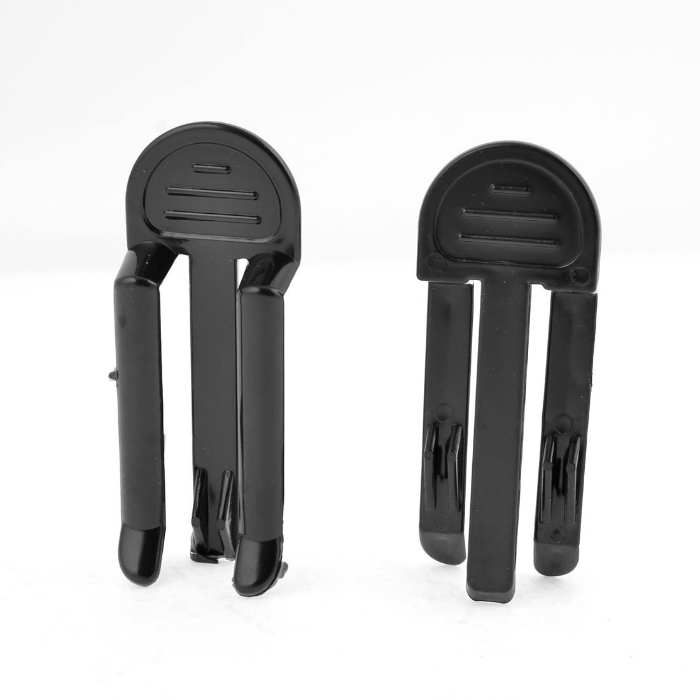

**Figure 6:** uxcell® Plastic Garbage Rubbish Trash Can Bag Clip Clamp Holder

Advantages:

* Does generally successfully hold the bag in place but is meant to be used for wide rimmed trash cans

Disadvantages:

* Has the tendency to not always hold the bag from falling in, when used on thinner 13 gallon kitchen trash cans
* Meant to be used on the top of the bag, and can get dirty when trash is thrown in
* Does not work with a lot of weight.

User Reactions:

* Generally does an acceptable job, but only if the user has a certain kind of trash can with a certain rim thickness
* It gets annoying to have to take them off and put them back on again after every time the trash bag is changed

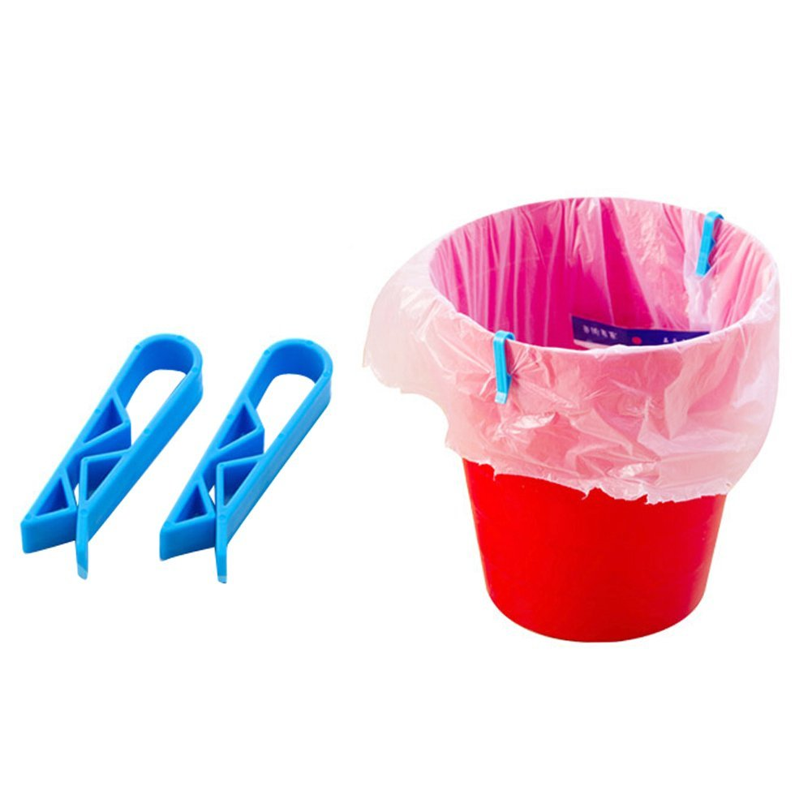

**Figure 7:** DELIFUR(TM) 12 Pieces Plastic Clip Clamp Holders, for Garbage Can

Advantages:

* Works on trash can up to 7 gallons
* Works pretty well on many widths of trash cans up to a certain width

Disadvantages:

* Tends to dirty easily due to sitting on top of the trash bag and can
* Has to be taken off every time the bag is changed

User Reactions:

* Does not work well with bigger trash cans
* Sometimes when the trash gets full, these pop off into the trash bag, and end up getting thrown out

**Summary of Insights**

Overall, these two products are very similar in their advantages, disadvantages, and reactions from users. Both products work on a smaller subset of trash cans, depending on width of the can and weight that the clips can hold. Both clips are not very strong, and they are both generally slippery making it easy for the bag to slip through. They pin on the outside of the bag on top of the rim which can make them dirty during use, as well as requiring the user to take them off and put them back on each time a bag is replaced.

After researching and testing these products, the product solution to be made would require the following:

1. Solution that goes under the bag and stays on the can
   1. Will stay cleaner
   2. Does not have to removed after each use
2. Solution must be able to fit around a majority of kitchen trash cans
3. Solution cannot be slippery and allow the bag to slip out of the product

# Brainstorming and Concept Refinement

Once the problem of the trash bag falling in was identified and certain requirements for a solution established, a brainstorming session was conducted. Over a period of 15 minutes, all members crudely drew out as many ideas as each could think of that would attempt to solve the problem at hand. The brainstorming and design process followed the double diamond model of design, described by Don Norman in *The Design of Everyday Things*. User surveys broadened the “trash problem” and then allowed the team to narrow down the root cause of these concerns. In both the problem-finding and solution-finding stages, the team “expand[ed] the scope of the problem, diverging to examine all the fundamental issues that underl[aid] it” (Norman, 2013, p.220). In this case, the fundamental issue was dirtied trash cans. The results of brainstorming solutions to fix this root cause can be seen in Figure 8.

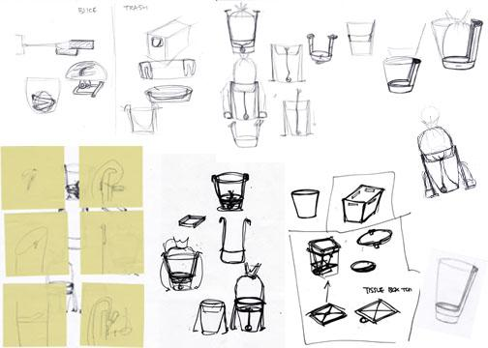

**Figure 8:** Results from brainstorming session

A majority of these brainstormed solutions focused on products that hold trash bags snugly to the can such that it would unlikely that the bag would fall in while throwing trash away. A few more interesting solutions also came up that addressed non-primary product solution requirements.

**Concept Refinement**

After brainstorming, ideas were refined into major categories of solutions so that the team could better understand how each set of ideas met product solution requirements.

*Idea 1:* Four different mechanisms to keep the trash bag on the trash can are shown below. These are simple and attractive, but the biggest concern with this approach is whether any of these solutions is appealing enough to replace the use of binder clips as they provide essentially the same solution space.

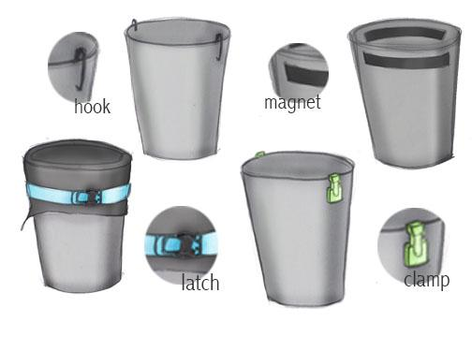

**Figure 9:** Hooks, magnets, latches, and clamps are all mechanisms identified as potential solutions

*Idea 2:* Inspired by tape free Amazon packaging, the design below could potentially reduce the hassle of changing trash bags. One stack of these could potentially hold through bags and the user could simply rip the current bag, take it out, and have a fresh new surface ready to use.

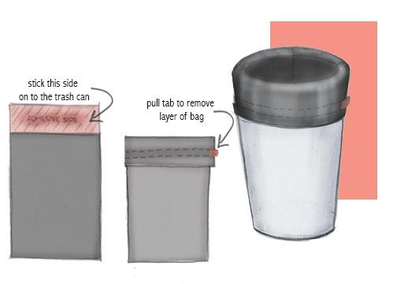

**Figure 10:** Adhesive could be used as part of the trash bag mechanism itself

*Idea 3:* This idea is inspired by an existing patent. The roll of trash bag is kept under the surface for continuous access to the bags. The surface is meant to collect any scraps, keeping the bottom of the trash can clean.

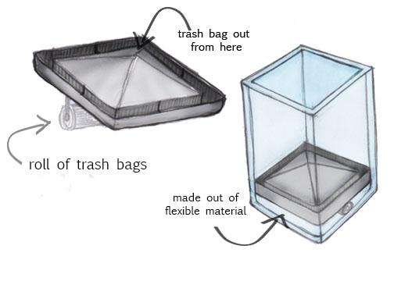

**Figure 11:** Roll of trash bags in bottom of can, spill catcher

**Concept Selection**

While ideas 2 and 3 were very intriguing and solve some secondary product solution requirements, they were discarded for a couple main reasons. In the end, idea 1 was picked because it had the capability of solving many, if not all, product solution requirements, as well as being iterated upon in the time allotted.

*Idea 3:* While the team believes that this is an interesting solution to some of the issues faced by users, it does not directly solve the need for a product that prevents a bag from falling in. Also, since it is similar to a patent that was found, there is not as much room to innovate through a product such as this.

*Idea 2:* Although this would seem to solve the problem of the bag falling into the trash can, it is reliant on partnering with a manufacturer of trash bags. Being that this solution is more of a manufacturing issue and there was no way to get in contact in the length of a quarter, this idea was scrapped.

*Idea 1:* Though these solutions are similar to a binder clip, there was the feeling that we could further refine these mechanisms in a way that would solve the product solution requirements laid out. Some more research, brainstorming, testing, and iterating needed to be completed before a final solution was designed.

# 

# 

# The DesignMech Clip H Render A.JPG

## 1. Product Summary

The Clip-It (Figure 12) is the unobtrusive, easy-to-use solution that holds trash bags in place where they are supposed to be: on the trash can, not slipping off the edge and not inside the can. Adaptable to one’s existing trash can, this product is an inexpensive addition that fits with a wide variety of basic kitchen trash cans that do not have features to secure the bag in place. Three to four clips can be placed on the can (Figure 13) and *left there* in what is a hassle-free way to prevent trash bags from slipping into the can while also acting as a reminder to clip one’s trash bag in place. 

## 2. Trash Can Attachment

The S-shaped can attachment feature allows for flexibility and adaptability to trash cans in a variety of styles. The spacing allows the product to fit over trash cans with large lips around their upper edge, but remains snug against the thinner wall of the can. The flexibility of this shape allows the product to stretch around bulky cans yet returns to its original shape thanks to the intermediary stiffness of the polypropylene-like material of the Connex 3D printer. This product used the blend DM8430, the third-stiffest material offered, in order to achieve this particular quality.

## 3. Bag Clip with Torsion Spring

To achieve the tight grip and hinging mechanism of the product, a torsion spring providing 1.473 in-lbs of torque was used. While smaller springs were tested, they did not provide the necessary clamping force to hold the thin bags in place. The selected spring, detailed below in Table 1 provided the appropriate force while remaining small enough to fit within the slim profile of the product design.

|  |  |  |  |  |  |  |
| --- | --- | --- | --- | --- | --- | --- |
| Spring Outer Diameter (in) | Wire Diameter (in) | Leg Length (in) | Max. Rod Outer Diameter (in) | Number of Coils | Torque  (in.-lbs.) | Spring Length  @ Torque |
| 0.309 | 0.040 | 1.250 | 0.187 | 4.25 | 1.473 | 0.198 |

**Table 1:** Torsion Spring Properties

The 14° angle between the the sides of the clip was determined through trial and error in assembling earlier clip prototypes, described in Appendix C. The legs of the torsion spring rest within grooves on the sides of the clip designed to prevent lateral movement of the spring. The spring successfully forces the the clip sides together, creating the necessary grip and providing the necessary clamping force to hold the bag securely in place.

## 4. Friction Surfaces with Plasti Dip

The end of the clip legs as well as the end of the can attachment were coated with Plasti Dip to provide a friction surface to grip the smooth and slippery trash bags. The Plasti Dip coating the clip legs was given a textured surface as it dried to further aid in gripping the bag. Coating the end of the can attachment prevents the Clip-It from sliding around by providing just enough friction to hold it in place at the desired location on the can. Despite this, the Clip-It still slides on and off of the trash can seamlessly should the user want to remove the clips for cleaning.

## 

## 

# Requirements and Specifications

The following requirements and specifications should be met by the product in order to meet the criteria of a successfully designed product.

|  |  |
| --- | --- |
| **Requirement** | **Specification** |
| Inexpensive | Less than $15.00 |
| Unobtrusive | Fits within a 2.25” by 2.25” by 2.25” box |
| Works when the bag gets heavy | Holds a bag filled with 15 lbs of weight |
| Easily cleaned | Cleaned within 3 minutes |
| Simple and easy to use | Determined via user testing |

*Inexpensive (less than $15.00):* Injection molding at the quantities detailed in Table 2 below could be driven down dramatically if production were in the tens or hundreds of thousands of units. However, producing only 5,000 units would allow a pack of four Clip-Its to cost $12.00 plus the cost of four bolts ($0.10 each) and four torsion springs ($1.15 each), totaling $17.00. This does not meet the current specification, but costs would decrease with bulk production and purchasing. At high quantities, the price of injection molding would likely be less than a dollar per part, with a pack of four likely being produced for less than five dollars, and being an affordable product.

|  |  |
| --- | --- |
| **Quantity** | **Cost per part ($)** |
| 1000 | 4.33 |
| 3500 | 3.67 |
| 5000 | 3.00 |

Table 2: Cost of Injection Molding

*Unobtrusive (fits within a 2.25” by 2.25” by 2.25” box):* Keeping the product profile and size slim ensures that it fits seamlessly within the user’s current lifestyle and habits. It fits easily around the can and does not stretch or deform the bag. The clip protrudes slightly as an indicator as to its placement but does not interfere with daily use of the trash can.

*Works when the bag gets heavy (holds a bag filled with 15 lbs of weight):* After measuring the weight of full trash bags, the maximum weight fell at 15 lbs of trash. While many trash bags are rated higher than this, these are extreme use cases that need not be considered as the standard for this product. In most of the static and dynamic load testing up to 15 lbs, the clips successfully held the bag in place (see Appendix D). Overloading the bag to 25 lbs cause the clips to begin to pull open, but the bag remained in placed.

*Simple and easy to use (determined via user testing):* Because the alternative solution of using binder clips to secure the bag to the trash can is both simple and easy to use, so too must this product be. User testing is detailed fully later in this report, but overall, users found the design to be intuitive and liked the fact that the product remains on the can between bag changes.

# Looks-Like and Works-Like Prototype

## 1. Early Prototypes

The picture (Figure 14) on the left are a few of the earlier mockups used to perform user testing. The three main aspects tested using these mockups were: clip orientation, mechanism for holding bag, shape of the clip holding on to the trash can. Through the user testing and brainstorming, it was determined downward orientation of clip, binder clip mechanism for holding bag, and S shape for the side holding the trash can were preferred. Although most users preferred the downward facing clip because it hid completely under the bag and reduced its chance of getting dirty, some users showed concern that the clip was hard to locate when hidden under the bag. This was a concern we looked into in later prototypes. Users were split when it came to the mechanism of holding the bag. Some users preferred how the magnet looked over the binder clip. In the end, binder clip was chosen because it ensured a secure grasp on the trash bag. Finally, S shape was chosen for the side holding the trash can. The main concern with the other option, pen clip, was that users showed frustrations that it got hooked onto rimmed trash cans. 

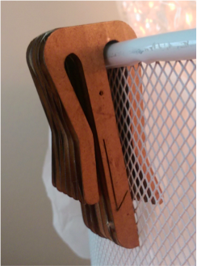

Before continuing on with this design, an alternative design was explored. The intent of this mock up (Figure 15) was to design something that was one form. The design, if successful, would have been a better alternative that would be easier to clean and cheaper to manufacture. For this prototype, the profile was laser cut and glued together. Feedbacks from user testing was positive, but the biggest problem with this mock up was that it wasn’t functional. The grip on the plastic bag was minimal. In hopes to make an improved prototype of this design, the next mockup (Figure 16) was created. This mockup was 3D printed using the Connex. The width of the side holding the trash can was widened to accommodate kitchen trash cans. The fit and form of it was perfect. The problem with this prototype was that the gap that was meant to hold on to the trash bag fused together. This mockup was crucial for realizing that the gap necessary to hold on the a trash bag was not feasible with the available resources. Although this design was put aside, it is very feasible to create the right spacing with technology such as injection molding.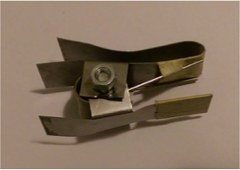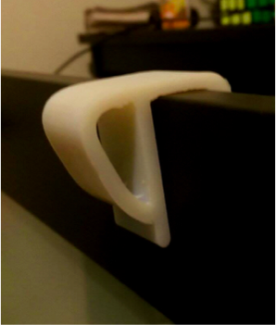

Returning to the initial mockup, the next iteration (Figure 17) was created to see if the rough mock up could be turned into an aesthetically pleasing product that took into account what was brought up during user testing. This mockup was created using sheet metals and a torsion spring. This mockup was also made to see if a binder clip mechanism can be blended into the design rather than stuck on. After confirming that the mechanism would work, parts were 3D printed using the MakerBot. The first of the 3D printing (Figure 18) was mainly a looks-like mockup. It was paired with the weakest torsion spring we had. This mockup further confirmed that the strength is comparable to the binder clip. For the next mock up (Figure 19) , it was scaled accordingly. Three different lengths were printed to compare and determine the best length. From testing these mockups, it was determined that the length between the shortest and the middle was the sweet spot. Plasti-Dip was also applied to enhance the grip of the clip. Grooves were also designed into the interior of the clip to hold the torsion springs in place. This was a very successful mockup. 

## 2. Final Prototype

The dimensions and angle are based on the mockups that came before the final prototype and are summarized in Appendix C. The final prototype was 3D printed using the Connex in the rapid prototyping lab. The Connex has the option of printing with flexible plastic. The flexibility of plastic was chosen as DM8430, the third stiffest plastic available. This polypropylene-like material provided the necessary flex to fit around different sized trash cans, but the opposite side of the clip became slightly deformed by the strength of the spring. Further testing can be done to determine the best hardness for the plastic in future iterations. The bolt and spring assemble the clip parts and create the hinging mechanism that is so essential to the Clip-It’s functionality. The ends of the product are coated with Plasti Dip to provide enough friction to both grip the bag as well as the can in order to hold the product in place. 

## 3. Manufacturing and Assembly

The simple nature of this design is best suited for injection molding. The thin and consistent wall thickness throughout the part promote even cooling of the part, while the curved S-shape minimizes warping. The hinge tabs could be drafted to prevent deformation and side pulls could be used to create the holes for the axial shaft. Either a standard bolt or an injection molded shaft with a sliding fit could be used to join the two parts in assembly and to serve as the axis of rotation for the spring. Currently both sides of the clip have two hinge tabs each, totaling four, but eliminating opposite tabs of each side, such that there are only two tabs in total, would ease injection molding and lower material costs, if only minimally. Having only one tab per part would eliminate the existing undercuts and simplify creating the necessary molds. While injection molded comes with large initial costs in milling the molds, mass producing these parts would allow for individual parts to be manufactured quite inexpensively. Production could be ramped up into the hundreds of thousands of parts, and further drive down costs, particularly since a Clip-It set would contain four individual clips to be used in tandem on a single kitchen trash can.

# Looks-Like and Works-Like Prototype Testing

## 1. User Testing

With the final prototype in hand, we approached 30 users to see how they felt about Clip-it. We handed them all four Clip-Its with a trash can and a trash bags. Based on the observations made, the final prototype was a huge success. The design ended up being intuitive. One of the users pointed out that the side that held on to the trash can resembled the shape of a trash can lip, making it intuitive. She felt this resemblance was crucial and also made it aesthetically pleasing. Not one person had to be told how to use the Clip-It. Most users did not have problems clipping on and off the trash bag from Clip-It. Some users that did struggle wished there was a better indicator of where the clip was. The downward facing design was chosen knowing this concern existed. Ultimately, it was chosen to design so that the product was fully covered over having the product exposed. To aid with this concern, one user suggesting having a texture feedback. Finally, a lot of the users were impressed by how well it worked. The users that were approached with the earlier mockups were especially amazed at how strong the Clip-It is.

There were also some concerns users brought up that could be addressed in the future. The biggest concern was regarding the stickiness of the plasti-dip. Although the layer of plasti-dip acts as an additional grip for the trash bag, it also tends to stick to each other. Another major concerns were the exposed torsion spring. Many users showed these common concerns. Another concern included the exposed torsion spring because it was a location that was hard to clean. The Cleanliness Test section will go more in-depth regarding this. Further information on User Testing can be viewed in Appendix E.

## 2. Static Load Test

After building the final prototype, performance testing was required to see how well the product met requirements. One of the requirements included being able to hold a bag of trash up to 14 pounds. The first test conducted to learn how well the Clip-It performed was a static load test. Using materials that were between 2-10 pounds, it was found that the Clip-It could easily hold up to 14 pounds of weight with little deformation and held the bag from falling in. By placing a couple more materials in the bag, it was found that the Clip-It could safely hold at least 23 pounds without the bag falling in. In order to save the prototype from being destroyed testing was stopped at 23 pounds. As can be seen below in Figure 21, one of the clips was opened from the force of the bag, but still held the bag in place. When the clip did fail they were caused by two main reasons: improper spacing of the clips and unequal weight distributed among the clips.The results from the test can be found in Appendix D.

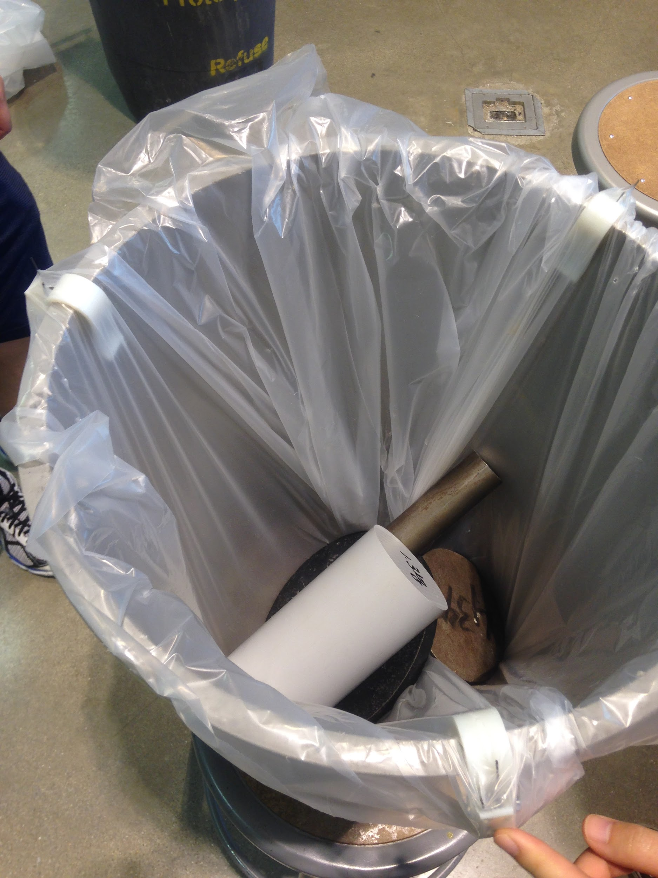

**Figure 21:** The Clip-It holding 25 lbs, with only one of four clips undone by the weight

## 3. Dynamic Load Test

After the static load test, a dynamic load test was performed. Reasoning that not many users would throw something away weighing more than 3 pounds, materials and tools weighing between ¼ pound to 3 pounds were used to throw into the bag while 4 Clip-Its held the bag in place. The Clip-Its did an amazing job and held up the bag throughout most of the test. In addition, none of the clips deformed or were opened during most of the testing. This test was stopped at 15 pounds because these were the only four prototypes that had been made. The few times the clips deformed was when the wrench got caught in the plastic bag, pulling more of the bag than it would have otherwise. The test results can be found in Appendix D.

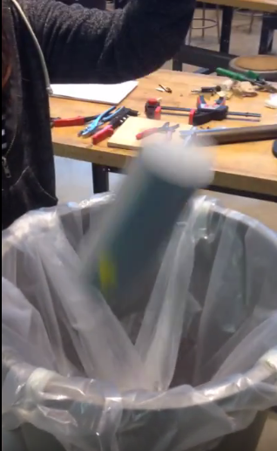

**Figure 22:** 3 pound weight being dropped into trash bag with Clip-Its attached

## 4. Cleanliness test

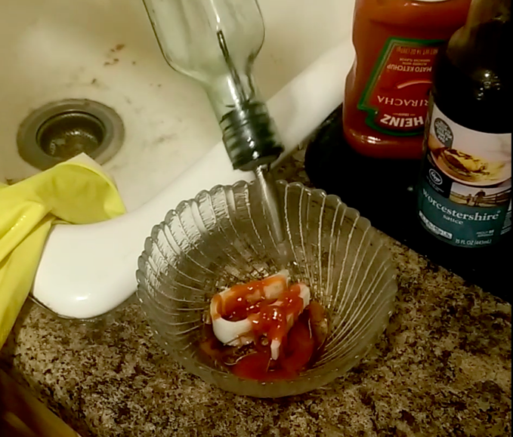

**Figure 23:** Clip-It drenched in ketchup, oil, and worcestershire sauce for cleanliness test

Having a final design that could be easily cleaned was one of the criteria. To meet this criteria, the alternative design that was one form and had no crevices was initially pursued. The alternative design did not perform as well, failing to hold a heavy load. In order to design a final product that is functional, a mechanical solution was pursued. The mechanical alternative would have crevices for the spring and the cleanliness criteria would not be met as well as the prior design. Although the cleanliness criteria was put to the side for a functional final product, the cleanliness test was still performed on the final prototype. As mentioned in the requirements and specifications section, in order to pass the cleanliness test, cleaning of the product must take less than 3 minutes. Although the final prototype passed the test, the Clip-It could be under worse conditions. The final prototype was drenched in ketchup, sauce, and oil. Realistically the stains would have dried up and would be harder to get off. A dried stain may take longer to get off than 3 minutes. To reduce the pain of cleaning, ideally it would be made dishwasher safe.

## 5. Findings and Insights

In general the strength test was a huge success. The final prototype withstood stronger forces than required and specified. Even with excessive force, the clip would open up but did not result in permanent deformation of the clip. Although it withstood a lot of force, further testing using different hardness of plastic could result in a more durable product. Regarding the cleanliness test, the problem would be resolved if the product is made dishwasher safe. Another consideration is to enclose the spring. Further elaboration is found in the Future Steps section.

# Future Steps

In order to be taken to market successfully, the Clip-It would require improvements and modifications that would allow it to have greater functionality and be easily manufactured. The most notable changes relate to making the product easy to clean by experimenting with different dishwasher safe materials and enclosing the spring to eliminate difficult-to-reach crevices. In terms of manufacturing, both the Clip-It and the earlier iteration of the “one form” design could be injection molded for mass production.

Polypropylene or polycarbonate may be appropriate choices due to their general rigidity, which is needed for the clip, without being too stiff and allowing some flex to fit over the trash can. Both are dishwasher safe and can be easily injection molded. The friction surfaces of the clip currently created via the application of Plasti Dip could be replaced with silicone grips or sleeves added to the product. Silicone’s inert, easy-to-clean, dishwasher-safe, and flexible nature give it the necessary properties to support the functions of the Clip-It.

Currently the largest issue with the cleanliness of this product is the exposed torsion spring. In future iterations, the spring would need to be enclosed with an additional piece, most likely a cylindrical cover that prevents debris from getting stuck in the spring’s grooves but still allows the necessary axial rotation. In addition to enclosing the spring, the bolt and nut would be replaced by a simple shaft having a sliding or transitional fit with the two sides of the clip. This would further reduce the areas that could easily dirty and would create a more streamlined look while having enough clearance to permit part movement. The shaft may need end caps that could snap into the outer sides of the Clip-It to prevent it from sliding loose.

In order to best mass produce and manufacture the Clip-It, design modifications for injection molding would be necessary. Undercuts created by the hinge tabs would need to be eliminated and sliding pins may need to be used to create the hinge holes for the rotating shaft. However, these modifications are all fairly minor and would allow the Clip-It to be mass produced at an inexpensive rate. Ideally, the earlier “one form” iteration of the product could be reevaluated and tested such that it could be redesigned for injection molding. This form of the product, if it successfully held a trash bag in place on the can, would be an incredibly simple shape to injection mold due to its smooth profile, fairly even wall thickness, and lack of detailed features. Both this form and the current Clip-It could be modified for injection molding, with the more functional product, being mass produced for market. Costs of injection molding the two iterations are shown in Table 3 below.

|  |  |  |
| --- | --- | --- |
| **Quantity** | **One Form: Cost per part ($)** | **Clip-It: Cost per part ($)** |
| 1000 | 2.28 | 4.33 |
| 3500 | 1.99 | 3.67 |
| 5000 | 1.69 | 3.00 |

**Table 3:** Costs of Injection Molding the One Form and Clip-It Iterations

# Differentiation

Why use the Clip-It? Why not just throw a few binder clips on the edge of the trash can?

The Clip-It is a unique, hassle-free, and clean solution that successfully holds trash bags in place in a sleek and unobtrusive manner. Because the Clip-It remains on the trash can between bag changes, the user need not worry about remembering to use this helpful product. With products that are removed between uses, they may be forgotten until the bag inevitably slips into the can, at which point the bag may be too heavy or burdensome to readjust successfully. Even worse, they may be lost and taken out with trash. The downward oriented clip, while unique and sometimes shocking to initial users, keeps the product covered and clean, requiring minimal maintenance over time. By blending in, the Clip-It stands out from the rest.

# 

# 

# References

Norman, D. A. (2013). *The Design of Everyday Things*. New York: Basic Books.

Thomson Innovation. Retrieved June 9, 2016, from http://info.thomsoninnovation.com/

# 

# 

Appendix A: Initial User Survey Responses

This survey received 23 responses from users ages 17-59, comprised of 34.8% males and 65.2% females. Below is a summary of the questions asked and respondents’ answers.



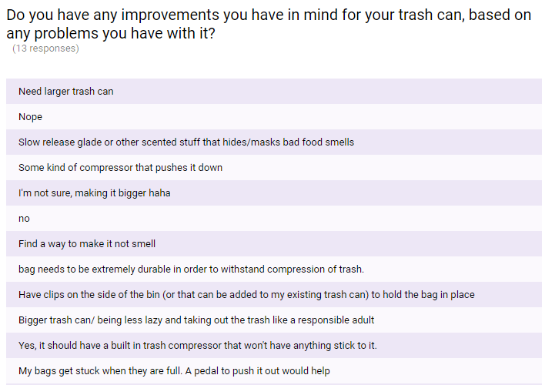



Appendix B: Patent Research

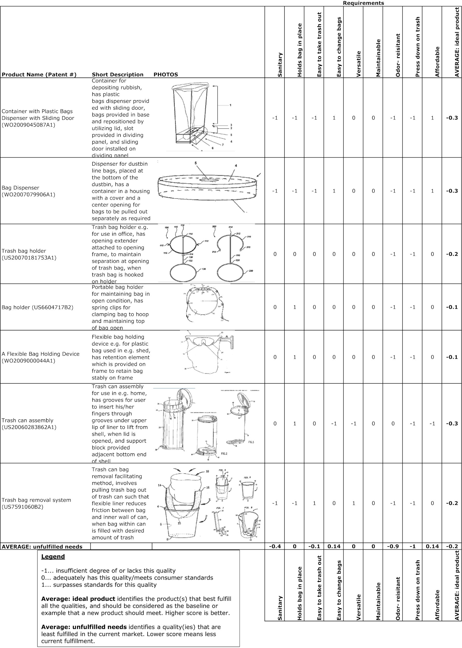

Appendix C: Angle Determination

|  |  |  |  |
| --- | --- | --- | --- |
| Angle of Hinge (degree) | Difficulty of Assembly | Comments on Width | Comments on Length |
| 11 | Impossible to assemble | -Slim profile  -Difficult to feel the clip under the bag | -Too long  -Requires too much bag length to secure |
| 13 | Average, but assembly is secure | -Clip edge protrudes just a bit as an indicator to its placement | -Slightly too long  -Requires too much bag length to secure |
| 17 | Easy, but assembly feels loose | -Wide profile  -Clip protrudes through and stretches bag | -Appropriate |

Impact on Final Design: The 13° angle provided most desirable assembly and width, but the 17° angle provided the shortest and most desirable length. The final prototype has a 14° angle with a length of $1\frac{1}{16}"$, similar to that of the 17° iteration. This was achieved by raising the axis of rotation so that the desired angle could be achieved without compromising the desired shorter length of the product.

Appendix D: Performance Testing Results

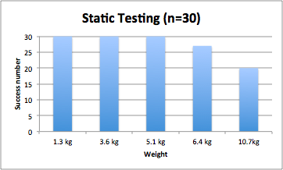

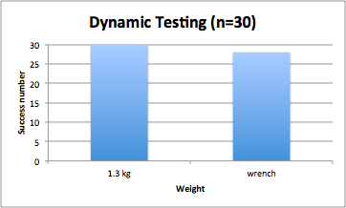

Appendix E: Final Prototype User Testing

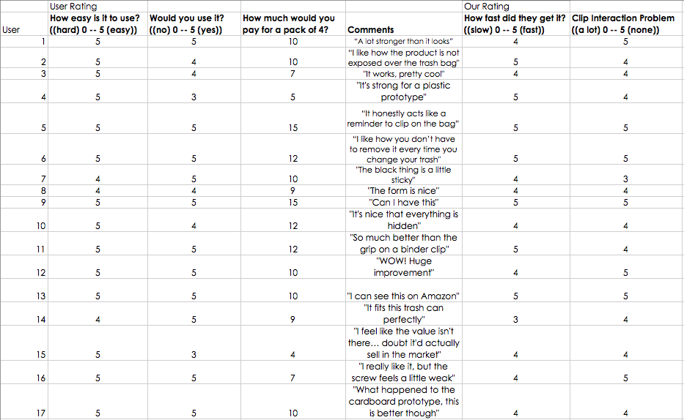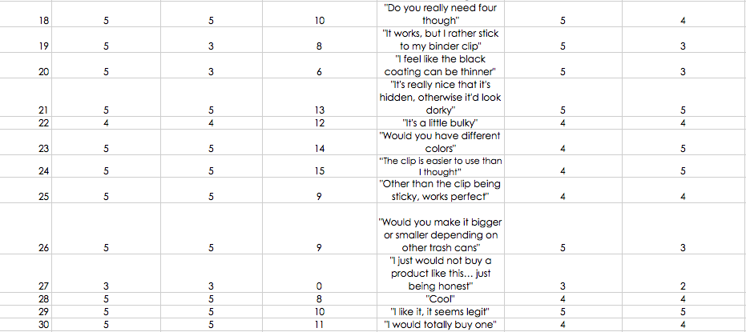

# Appendix F: Dimensioned Drawings

## Clip-It: Backing

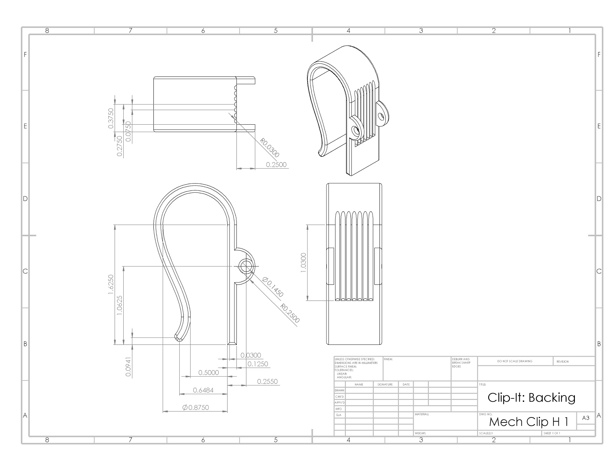

## Clip-It: Clamp

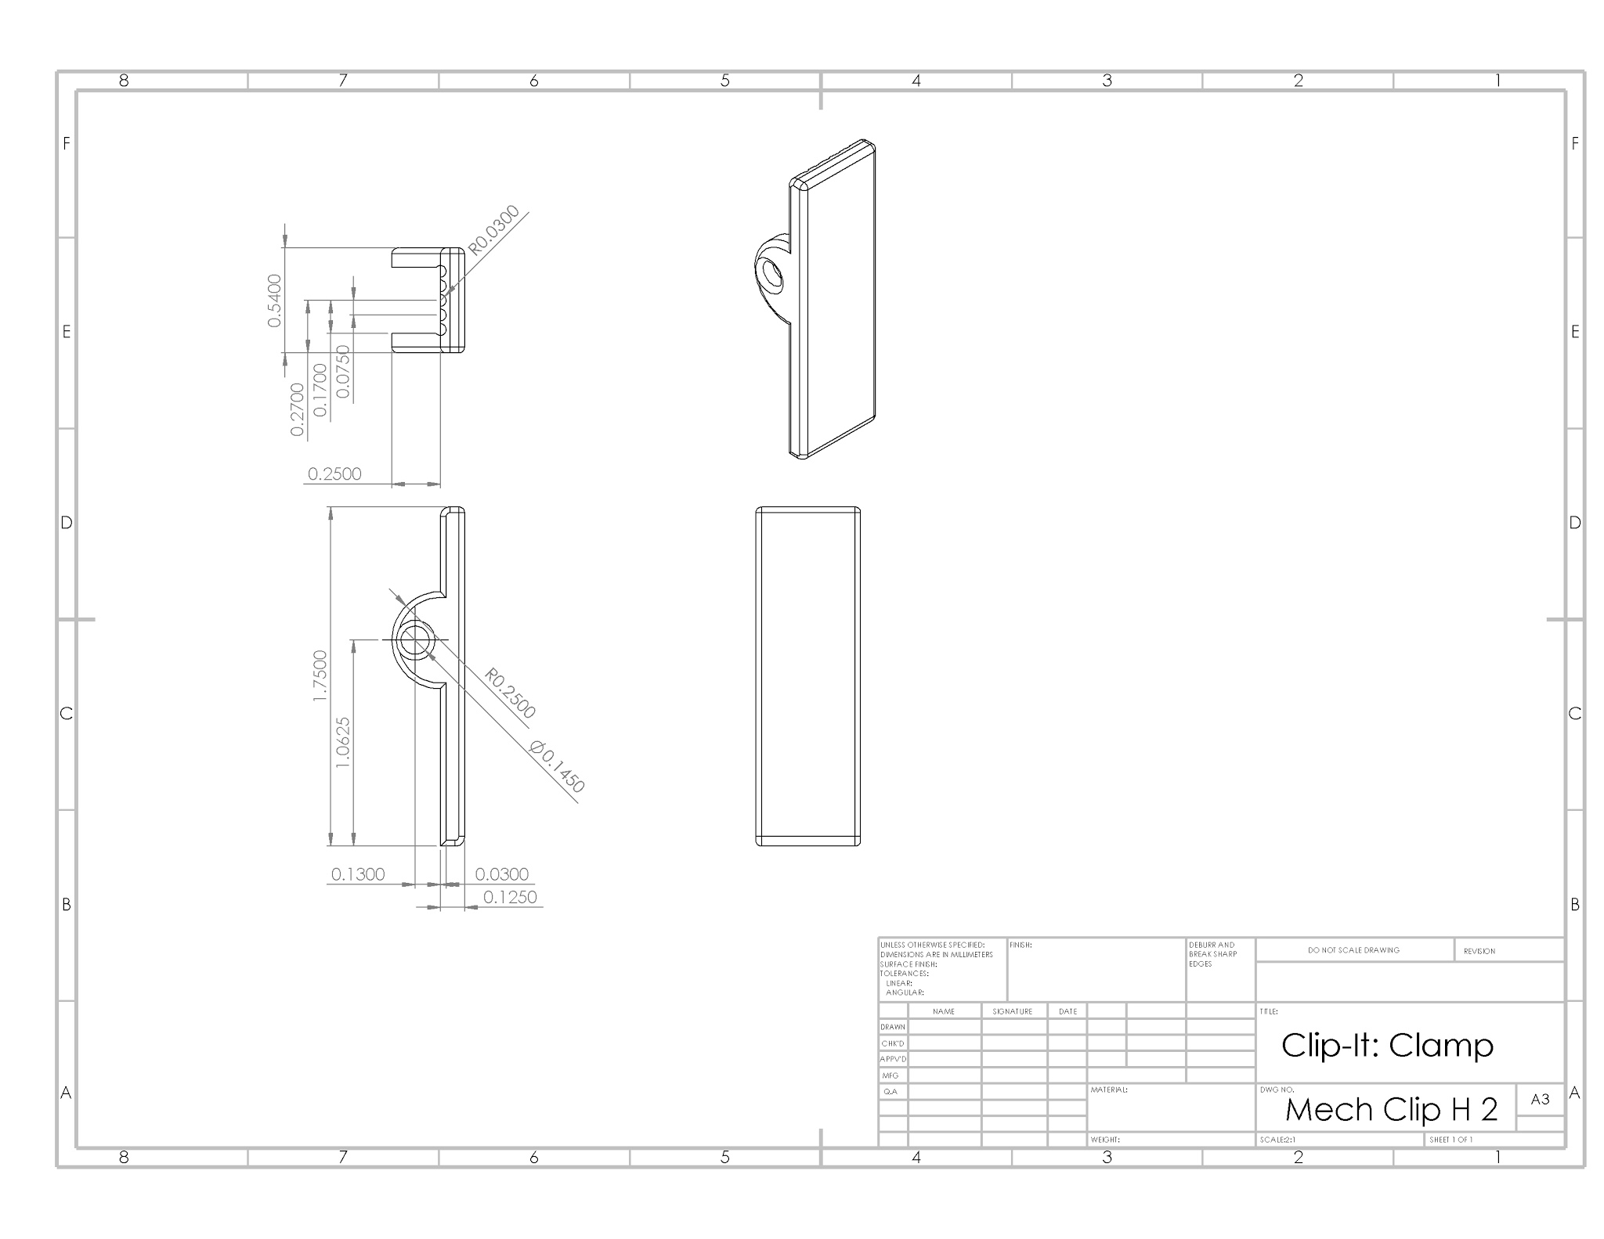

## Clip-It: Full Assembly

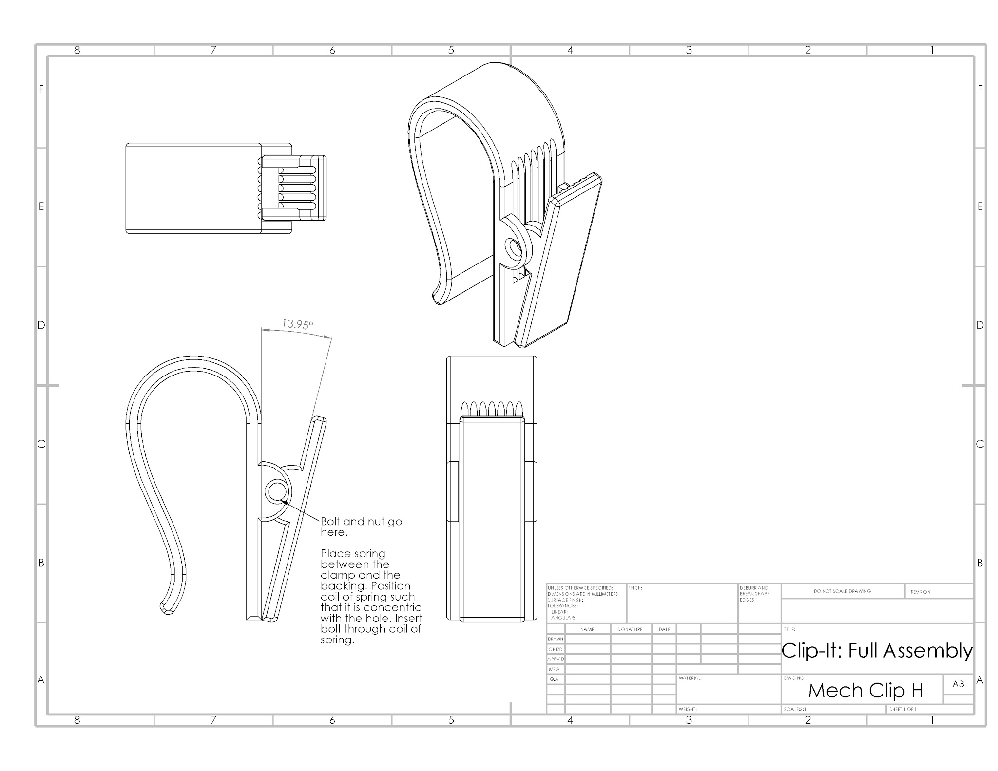

Appendix G: Bill of Materials

